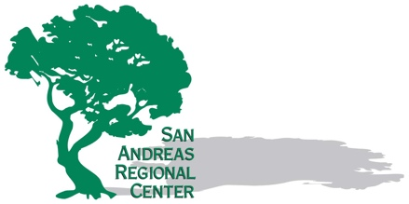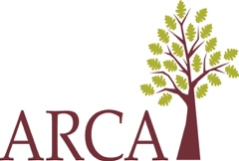

加州《蘭特曼法案》的製定主要考慮了兩大目標，旨在幫助發育性殘障人士及其家庭。首先，該法案旨在維護家庭的團結，並滿足與殘障人士相關的家庭單元的需求。其次，長期以來，該法案的重點是支持殘障人士積極參與社區事務。但最近發生的事件讓一些人擔心，他們如何與家人團聚，並繼續融入社區。

區域中心始終致力於支援所有符合服務資格的加州居民。保護個人隱私是區域中心向其服務對像做出並恪守的核心承諾。我們僅收集滿足以人為本需求所需的資訊。

正如發展服務部最近發布的社區資訊所述，如果您或您的家人的服務需求發生變化，請聯絡您的服務協調員。他們可以幫助您滿足緊急需求，並探討如何調整您的多項服務，包括根據您的偏好選擇遠端服務。

區域中心的工作人員很榮幸能夠與服務對象攜手同行，無論順境逆境。歡迎隨時聯絡他們。在這個充滿不確定性的時期，他們會為您提供支持。

California’s Lanterman Act was developed with two primary goals in mind for individuals with developmental disabilities and their families. First, there was an interest in keeping families together and meeting the needs of the family unit related to the individual’s disability. Second, a long-standing focus has been supporting people with disabilities to actively participate as active members of their communities. Recent events have left some people worried about how they can stay together with their families and continue accessing their communities.

Regional centers remain committed to supporting ALL Californians who are eligible for their services. Protecting individual privacy is a central promise regional centers have made and kept to those they serve. Only the information needed to meet people’s person-centered needs is collected.

As the recent community message from the Department of Developmental Services explained, if you or your family member have changing service needs, please reach out to your service coordinator. They can help you meet your urgent needs and explore ways many of your services should change, including being provided remotely if that is your preference.

Regional center staff have the honor of walking along people they serve in good times and bad. Do not hesitate to reach out to them. They are there to support you during this uncertain time.

